  Office of the Principal  SGBIT, Belagavi | S. S. Education Trust’s CET Code: E-175 (UG)/T-942 (PG)  S. G. BALEKUNDRI INSTITUTE OF TECHNOLOGY  Shivabasavanagar, Belagavi- 590 010, Karnataka- India  Office: 0831-2407172, 2554559 Fax: 0831-2407152  Email: principal@sgbit.edu.in, sgbitbelgaum@gmail.com Website: www.sgbit.edu.in | 
 | Approved by AICTE New Delhi Recognised by Govt. of Karnataka  Affiliated to V T U, Belagavi An ISO 21001:2018 Certified Institution  UG Programs CV, ME, EEE, ECE & CSE are Accredited by NBA, New Delhi (Valid upto 2026-27) | 

Title of the Project :

Integrated Smart Safety & Traffic Monitoring System

Name of the Project lead : Bhavana Tele (CSE)
Team Members : Gouramma Narasannavar (CSE)
Jyoti Odeyar (CSE)
Ganesh S H (CSE)

Mentor :
Introduction & Background

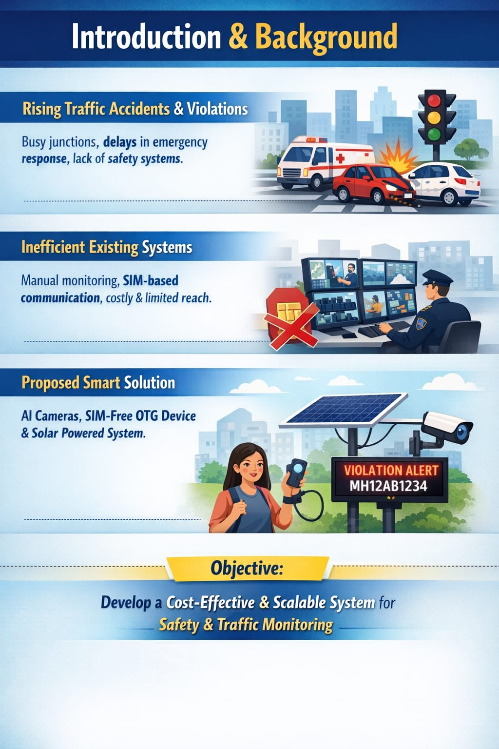
The idea for this project originated from the increasing number of road accidents and traffic violations observed in daily life, especially at busy junctions and urban areas. At the same time, many people face difficulties in getting immediate help during emergencies due to delays in communication and lack of proper safety systems. This highlighted the need for a smart and reliable solution that can address both personal safety and public traffic management.
The problem mainly lies in the inefficiency of existing systems, which depend heavily on manual monitoring or require SIM-based communication. Traffic violations often go unnoticed, and emergency response systems are slow or inaccessible. Additionally, most available solutions are expensive and not suitable for widespread implementation, especially in developing regions.
To overcome these challenges, this project proposes an integrated system that combines a SIM-free OTG-based safety device with an AI-powered traffic monitoring system. The traffic system uses smart cameras, LED displays, and solar energy to automatically detect and report violations, while the OTG device ensures quick emergency alerts and location tracking.
The main objective of this project is to develop a cost-effective, efficient, and scalable solution that enhances both individual safety and road discipline. By integrating technologies like AI, IOT, and renewable energy, the system supports smart city development and ensures a safer environment for the public.
Problem Statement :
In today’s society, women, children, and senior citizens continue to face critical safety risks, especially during emergencies such as accidents, health issues, or unsafe situations. A major challenge is that most existing safety systems rely heavily on internet connectivity, making them unreliable in remote areas, low-network zones, or during network failures—precisely when immediate help is needed the most.
This creates an urgent need for a dependable, real-time safety solution that functions completely without internet access, ensuring uninterrupted protection. The lack of instant alert mechanisms, location tracking, and emergency response in offline conditions significantly increases vulnerability and delays assistance.
At the same time, rising traffic violations such as reckless driving and rule-breaking are endangering public safety. Current systems lack automation and sustainability, especially in areas with limited power resources.
To address these challenges, there is a strong need for an intelligent, offline-capable safety device integrated with features like SOS alerts (manual and voice), accident detection, air quality monitoring, and GPS tracking. Additionally, a solar-powered automated traffic monitoring system is required to detect and display offenders in real-time, promoting discipline and ensuring safer communities through reliable, independent, and sustainable technology.
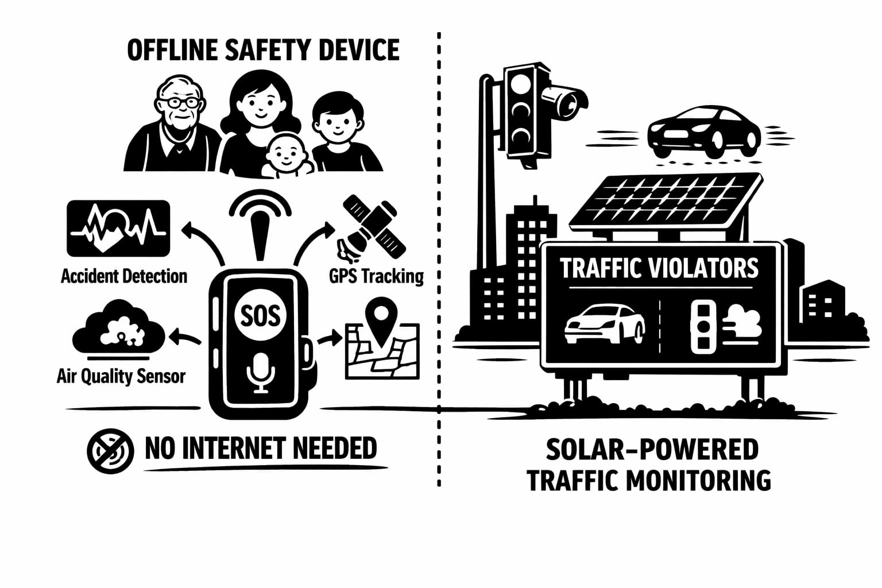
Review of Technology :
Many safety solutions are already available for women, children, and senior citizens. These include mobile apps, smart wearable devices, and GPS tracking systems. Most of them provide features like SOS alerts, location sharing, and emergency calling. Some advanced systems also use sensors to detect accidents or unusual activities.
However, most of these solutions depend on internet or mobile networks, which makes them less useful in remote areas or during network failure.
In traffic monitoring, systems like CCTV cameras and automatic rule detection are used to identify violations such as signal breaking and over-speeding. These systems are effective but require continuous electricity, internet, and high-cost infrastructure.
Overall, existing technologies help improve safety and monitoring, but they are not fully reliable in all situations. There is still a need for a low-cost, automatic system that can work without internet and provide continuous safety and monitoring

Limitations
Understanding Existing Technology Gaps :
CCTV Monitoring
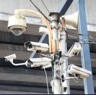
CCTV-based monitoring systems are often costly and require reliable internet connectivity, making them unsuitable for many areas, especially where infrastructure is lacking or unstable.
GPS Safety Apps

GPS and safety applications are heavily reliant on user participation and network connectivity, limiting their effectiveness in real-time traffic monitoring and emergency responses.
SIM-Based Devices

SIM-based alert devices incur recurring costs and have limited automation, reducing their practicality and accessibility for widespread implementation in traffic safety solutions

Innovation Approach :
New solutions for safer roads

OTG Device :

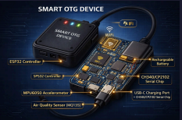
The SIM-free OTG-based personal safety device offers reliable emergency alerts and extensive functionality while ensuring users remain connected without network dependencies.

AI Cameras :

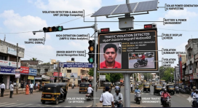
Our AI-powered 360° traffic violation detection cameras utilize advanced algorithms to identify violations, significantly improving enforcement efficiency and enhancing overall traffic safety monitoring.

Real-time Alerts :

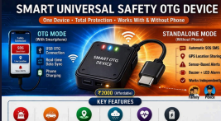
The system sends real-time alerts to authorities and users, ensuring prompt responses during emergencies and facilitating better coordination between traffic management and emergency services
System Architecture :
- SIM-free OTG safety device :

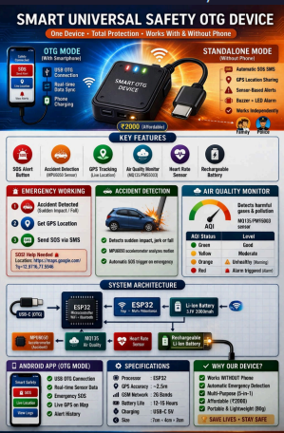
- AI-based traffic violation detection :
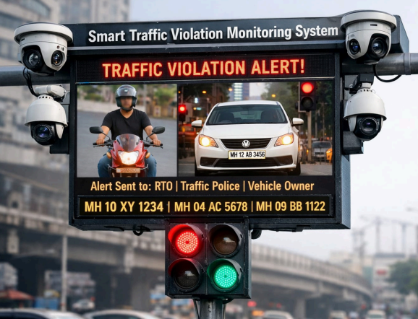

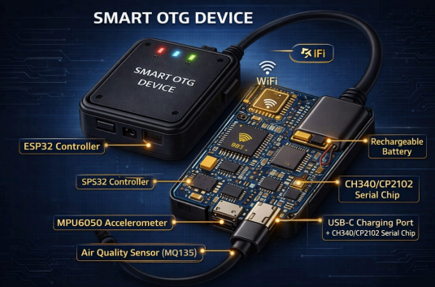
1) SIM-free OTG safety device :
- OTG-based smart device
- Connects directly to smartphone
- Uses sensors and mobile app
- Provides multi-safety features
Key Features:
- SOS Button
- Voice SOS (Hands-free)
- Accident Detection
- Air Pollution Detection
- GPS Location Tracking

2) AI-based traffic violation detection :
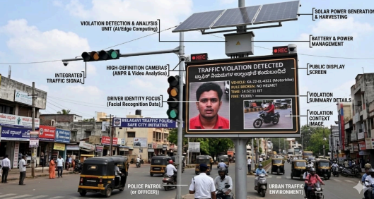
System Overview (Traffic Control Project)
- AI-powered cameras monitor traffic from two major directions at intersections.
- The system detects violations like red-light jumping and improper turns.
- A smart LED display instantly shows the vehicle number and issues a warning.
- Solar power ensures continuous operation and provides real-time alerts to authorities.
**Key Features**
- Equipped with dual AI cameras offering wide-angle coverage.
- Utilizes AI for real-time violation detection.
- Features a smart LED display for immediate public warnings.
- Sends automatic alerts to traffic police and the RTO.
- Employs license plate recognition through OCR technology.
- Operates on solar power with a battery backup.
- Supports data storage for evidence and analytical purposes.
- Designed to be cost-effective and scalable.

Methodology & Work Plan:
OTG SMART SAFETY DEVICE
Research & Planning
This phase is about understanding the problem and planning the system properly before building anything.
- Market Research
  - Study existing safety devices and OTG-based solutions
  - Identify user needs and gaps in current products
- Requirements Definition
  - Define what the device should do (features, safety functions)
  - List hardware and software requirements clearly
- Feasibility Study
  - Check if the project is technically and economically possible
  - Analyze components like sensors, OTG support, power needs
- System Architecture Design
  - Plan how hardware and software will connect
  - Create block diagrams for the system (microcontroller, sensors, mobile interface)
Development & Integration
This phase focuses on actually building and connecting the system components.
- Hardware Development
  - Select and assemble components (microchip, sensors, GPS module, etc.)
  - Build the physical device prototype
- Firmware Programming
  - Write code for the microcontroller
  - Control how sensors and hardware behave
- Mobile App Development
  - Create an app for monitoring and controlling the device
  - Ensure it connects via OTG or Bluetooth/Wi-Fi
- GPS Integration
  - Add location tracking to the system
  - Enable real-time location monitoring for safety
- System Integration
  - Combine hardware, firmware, and mobile app
  - Ensure all components work together smoothly

Testing & Finalization
This phase ensures the system works correctly and is ready for use.
- Unit Testing
  - Test each component individually (sensors, microcontroller, app)
- System Testing
  - Test the full system as a whole
  - Check communication between all modules
- Bug Fixing
  - Identify and fix errors in code or hardware behavior
- User Testing
  - Test the device with real users
  - Collect feedback on usability and performance
- Final Deployment
  - Finalize the design
  - Prepare the device for real-world use or presentation

SMART TRAFFIC DISPLAY MONITORING SYSTEM

Research & Planning
This phase focuses on understanding the problem and designing the system properly before building it.

Problem Analysis
- Identify issues in current traffic management (accidents, rule violations, congestion).
- Define the exact problem your system will solve.
- Set project goals like improving safety and automating monitoring.

Study of Traffic Systems
- Learn how traffic signals, road rules, and monitoring systems work.
- Understand how violations like red-light jumping or wrong turns occur.
- Study existing smart traffic solutions for reference.

Camera Selection (HD/PTZ)
- Choose the right type of camera:
  - HD cameras for clear image capture.
  - PTZ (Pan-Tilt-Zoom) cameras for wide and adjustable coverage.
- Ensure the camera supports real-time monitoring and good image quality.

AI Model Planning
- Decide how AI will detect violations (object detection, classification).
- Select suitable models (e.g., for vehicle detection or plate recognition).
- Plan training data requirements.

System Architecture Design
- Design the complete system flow:
  - Camera → AI Model → Server → Database → Display/Alerts
- Create block diagrams showing how components connect.
- Define hardware and software structure.

Development & Integration
This phase focuses on building the system and connecting all components.

Camera Installation
- Install cameras at strategic traffic locations.
- Ensure proper angle, lighting, and coverage of roads/intersections.
- Test video feed quality.

AI Model Development
- Train and develop the AI model for detecting vehicles and violations.
- Use datasets to improve accuracy.
- Test the model with real-time video input.

Number Plate Recognition (OCR)
- Implement OCR (Optical Character Recognition) to read license plates.
- Extract text from captured vehicle images.
- Store plate numbers for identification and tracking.

LED Display Setup
- Install LED display boards at traffic points.
- Show alerts like:
  - “Red Light Violation”
  - “Speed Warning”
- Provide real-time feedback to drivers.

Server & Database Integration
- Set up a backend server to process and store data.
- Use a database to store:
  - Vehicle details
  - Violation records
  - Time and location data
- Enable remote monitoring and data access.

System Integration
- Combine all components:
  - Camera + AI + OCR + Server + Display
- Ensure smooth communication between hardware and software.
- Check real-time data flow.

Testing & Finalization
This phase ensures everything works correctly and is ready for deployment.

Real-time Testing
- Run the system in real-world conditions.
- Check live video processing and response time.
- Verify system performance under continuous operation.

Violation Detection Testing (Red Light, Wrong Turn)
- Test if the system correctly detects:
  - Red light violations
  - Wrong turns
  - Other traffic rule violations
- Measure accuracy and detection speed.

Debugging & Optimization
- Identify and fix errors in AI models, software, or hardware.
- Improve system speed and accuracy.
- Optimize resource usage.

Data Storage Testing
- Check if all detected violations are stored correctly.
- Ensure database is reliable and secure.
- Test retrieval of stored data for reports.

Final Deployment & Demo
- Deploy the system in a real or simulated environment.
- Prepare a demonstration for your project presentation.
- Showcase:
  - Live detection
  - Alerts
  - Data storage and reports
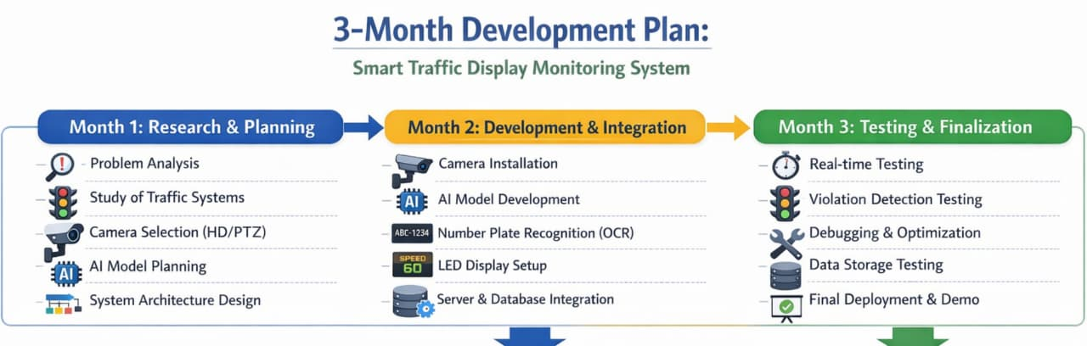
Time line :
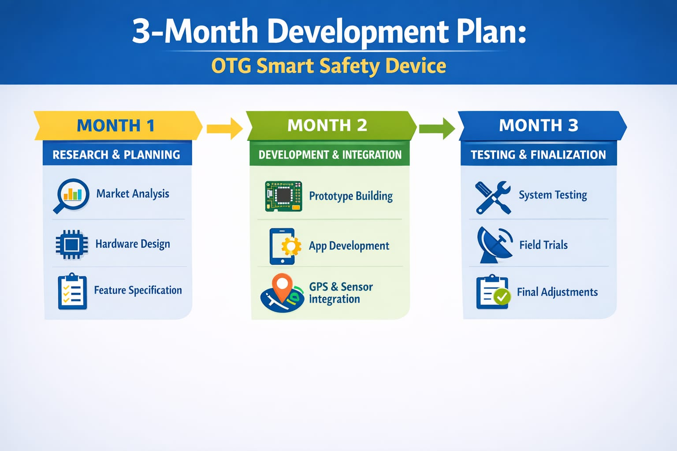
OTG SMART SAFETY DEVICE-TOTAL
BUDGET
Category | Item | COST
Hardware Cost | ESP32 Development Board | ₹ 800
 | NEO-6M GPS Module | ₹ 1000
 | MPU6050 Sensor | ₹ 300
 | MQ135 Air Sensor | ₹ 500
 | OTG Connector | ₹ 300
 | PCB/Wires/Casing | ₹ 300
Total Hardware Cost |  | ₹ 3,200
 |  | ₹ (4,000)
Software Development Cost | Android App Development | ₹ 5,000
 | Embedded Programming(ESP32) | ₹ 2,000
 | Testing & Debugging | ₹ 2,000
Total Software Cost |  | ₹ 9000
Final OTG Total |  | ₹12,200
 |  | ( Approx ₹13,000)

SMART TRAFFIC CONTROL SYSTEM: TOTAL BUDGET
Component | cost
Hardware Cost
LED Display Panel (Outdoor) | ₹ 1,20,000
AI Cameras (2 units, HD/PTZ) | ₹ 80000
Processor (Raspberry Pi 4) | ₹ 20000
Motorised Camera Mount (2 units) | ₹ 30000
Storage (1TB HDD/SSD) | ₹ 8000
Microcontroller (ESP32/Arduino) | ₹ 5000
Power Supply & Wiring | ₹ 12000
Installation & Setup | ₹ 15000
Total Hardware Cost | ₹ 290000
AI Violation Detection + OCR | ₹ 80000
Backend Server + Database | ₹ 30000
Basic Mobile App / Dashboard | ₹ 30000
Testing & Integration | ₹ 20000
Total Software Cost | ₹ 160000
FINAL TOTAL COST | ₹ 450000

Advantages
Key benefits of our system
- No SIM required (works using OTG connection)  - Low cost and affordable for everyone Portable and easy to use  - Instant SOS alerts during emergencies  - Real-time location tracking using GPS  - Can detect accidents automatically  - Works even without internet (basic features) Useful for personal safety (students, women, elderly) | - Utilizes solar energy to minimize reliance on electricity.  - Operates uninterrupted during power outages. Automatically identifies traffic violations, eliminating the need for manual monitoring. Provides real-time notifications to traffic authorities and regional transport offices. Enhances road safety, contributing to accident reduction.  - Encourages better traffic discipline among motorists.  - Offers long-term cost savings due to minimal maintenance and zero electricity expenses. Archives data for future analysis and use as legal evidence.  - Simple to enhance with additional cameras if needed.  - Ideal for implementation in both smart cities and rural regions.
Advantages of OTG Smart Safety Device Advantages of Smart Traffic Control System

Future Scope OTG:
Smart Safety Device Integration with wearable devices like smart bands and watches Direct connection with emergency services, such as ambulance and police AI-based accident prediction and health monitoring Miniaturization into a compact chip or device Integration with mobile apps for a real-time tracking dashboard Voice activation for hands-free SOS alerts Battery backup for independent operation without a phone Solar-powered system integration for energy-efficient and sustainable operation

Future Scope of Smart Traffic Control System :

Integration with smart city infrastructure AI-based traffic prediction and congestion control Automatic e-challan generation system Integration with government vehicle databases Addition of speed detection using radar sensors Facial recognition for driver identification (future use) Cloud-based system for centralized monitoring across cities Incorporation of a solar-powered system for energy efficient and sustainable operation

Team Commitment


Our team is dedicated to continuous innovation, ensuring our project delivers exceptional safety benefits and real-world applications.
Thank You

